Statement of Environmental Effects

Accompanying a development application for

Accommodation cabins at Coleambally Community Club

At

Lot 115 DP 236144

3 Falcon Road Coleambally

10 July 2024

Contents

1. Introduction 3

2. Site description and analysis 4

2.1 Location and context 4

2.2 Site description 4

2.3 Surrounding development 5

3. Details of proposal 5

3.1 Proposed works 5

4. Clause 4.15 -Matters for consideration 6

4.1 State Environmental Planning Policies 6

4.2 Murrumbidgee Local Environmental Plan 2013 6

4.3 Darlington Point & Coleambally Development Control Plan 6

4.4 Assessment of impacts 6

4.5 Suitability of the site 7

4.6 Public interest 7

5. Conclusion 7

# Introduction

This statement of environmental effects has been prepared by Coleambally Community Club to accompany a development application for accommodation cabins at Coleambally Community Club at Lot 115 DP 236144, 3 Falcon Road Coleambally. The application is being lodged by Chris Hardy, pursuant to Clause 4.12 of the Environmental Planning and Assessment Act 1979.

The proposal has been designed to achieve the relevant provisions of Murrumbidgee LEP 2013, and Clause 4.15 of the Environmental Planning and Assessment Act 1979 (as amended).

**Description of proposed development:**

Stage one of the proposed development involves the placement of 7 dual occupancy transportable accommodation cabins accommodating up to 14 persons and stage two to involve 3 – 5 units of family style accommodation.



Image 1. Proposed units

# Site description and analysis

## Location and context

The subject land to which this development application relates is described as Lot 115 DP 236144, 3 Falcon Road Coleambally. The land has one public road frontage, Falcon road to the west. There is also an internal road to the north that services the Coleambally sports ground.

Development surrounding the subject site is primarily zoned RE1- public recreation to the north, east and south, with RU5-village zoned to the west.

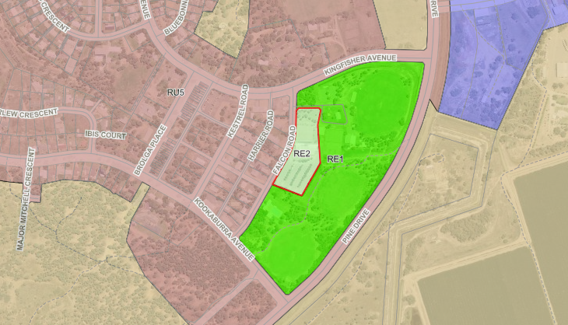

Subject site

**Figure 1. Site locality**

## Site description

The lot is irregular in shape, approximately 1.63 hectares in size. The site has approximately 215 metres frontage to Falcon Road to the west, a bitumen sealed road, with existing access to the carpark area.

The site includes a licensed club, that being the Coleambally Community Club, including club house and restaurant, bowling greens and an extensive carpark area.

The land is zoned as RE2 – Private Recreation and is not affected by any easements. The site is relatively flat with a slight fall to the southeast of the property with substantial vegetation that has been planted around the carpark area.

The land is mapped by NSW RFS as being Bushfire prone land. The distance of the site to the nearest area of continual native vegetation considered to be a fire risk is approximately 223 metres. It is considered that the Bushfire Attack Level is a BAL low. Please refer to the attached Bushfire Assessment.

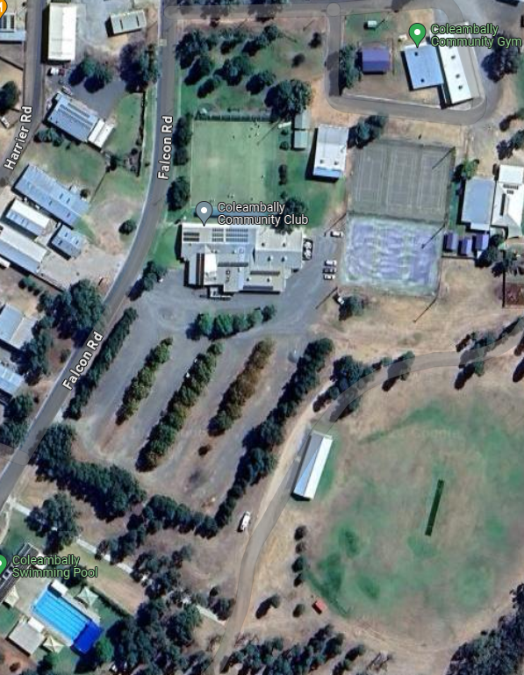

**Figure 1: Subject site**

## Surrounding development

The site is encompassed to the north, east and south by public recreation land, including a recreation ground to the east and north, including netball and tennis courts football ovals and community gymnasium and pre-school and a public swimming pool located to the south of the site. Commercial sites are located directly to the west with residential dwellings located further to the south on Falcon Road.

# Details of proposal

## 3.1 Proposed works

The development is proposed to be located along the eastern boundary of the existing carpark.

The proposed works will entail the following stages:

Stage 1. Involves the placement of 7 dual transportable accommodation cabins (up to 14 persons) and attached car park spaces.

Stage 2. Involves 3 – 5 family style accommodation transportable units and attached car park spaces.

Stage 3. Connection of cabins to existing water and sewer.

# Clause 4.15 -Matters for consideration

The following provides an assessment of the proposal against the provisions of Clause 4.15 of the Environmental Planning and Assessment Act (as amended).

## 4.2 Murrumbidgee Local Environmental Plan 2013

The proposed development meets the objectives of the objectives of the zone:

*To enable land to be used for private open space or recreational purposes.*

The site will continue to be used for recreational purposes and substantial open space will remain.

*To provide a range of recreational settings and activities and compatible land uses.*

Tourist and visitor accommodation is a compatible land use in RE2-private recreation.

*To protect and enhance the natural environment for recreational purposes.*

A substantial amount of existing planted non-native vegetation will remain on the site.

No development standards listed within the LEP apply to the development.

## 4.3 Darlington Point & Coleambally Development Control Plan

The Darlington Point & Coleambally Development Control Plan (DCP) has limited provisions relating to the development. Controls however, are listed for parking spaces as below:

|  |  |
| --- | --- |
| **Control** | **Consideration** |
| **Motel - One space per unit plus one space per employees plus one space for ever three seats if a public restaurant and/or function room is included** | Each unit will have a dedicated parking space. |

## 4.4 Assessment of impacts

|  |  |
| --- | --- |
| **Impact** | **Consideration** |
| **Environmental**  **(*natural and built environments)*** | The development is ancillary to the existing club and carpark, no environmental impact is |
| **Social & economic** | The proposed development will assist in filling an accommodation shortage within the town of Coleambally and surrounds for visitors and tourists.  Economic benefits include increasing visitation to the area. |
| **Visual impacts** | Low – considered ancillary to existing development |
| **Overshadowing & privacy** | N/A |
| **Noise** | The proposed accommodation units are fabricated off site therefore on site construction noise will be limited.  The ongoing use of the development will limit noise with controls in place with noise limitations on the occupants of the accommodation. |
| **Disabled access** | One unit will be accessible |
| **Security & safety** | The proposed development does not pose any security or safety issues. |
| **Services** | Reticulated water, sewer, power and waste removal is available to the site. |
| **Waste management** | Waste created from construction will be kept in a suitable waste receptacle and disposed of appropriately.  Waste created by the ongoing use of the development will be managed with the weekly Council waste removal service. |
| **Traffic** | Access to the site and units will be from an existing access from Falcon Road.  The carpark is currently underutilised, with an area of approx. 7300m2. The area on which the development will occur is 1650m2 leaving an area of approximately 5650m2 for car parking for the existing club and restaurant. Each cabin will have dedicated car parking adjacent to the cabin for the use of the occupants. |
| **Stormwater/flooding** | Stormwater is to be connected to existing services. |

## 4.5 Suitability of the site

The site is suitable for the development and is ancillary to the existing development.

## 4.6 Public interest

The proposed development will assist in filling an accommodation shortage within the town of Coleambally and surrounds for visitors and tourists.

# Conclusion

The development meets the requirements of 4.15(1) of the *Environmental Planning and Assessment Act 1979* and is permissible within the RE2 zone as tourist and visitor accommodation.